Configuring JDBC in TomEE

You can configure a JDBC driver for the entire TomEE application server or for a specific webapp. Regardless of which way you choose to do it, the configuration syntax is the same.

*NOTE: You can also configure a JDBC DataSource directly within an @Resource annotation but this is not recommended and is not covered here.*

The TomEE Resource Configuration Element

Here is a partial example of how you would configure a JDBC data source for Oracle.

<Resource id="Oracle Database" type="DataSource">

// driver properties go here

</Resource>

We’ll fill in the driver properties in a bit, for now let’s focus on the <Resource> element’s attributes id and type.

*NOTE: Within the <Resource> element values for id and type attributes allow for spaces and are not case sensitive.*

**JDBC Resource Attributes**

There are several possible attributes that can be set on the <Resource> element, but the most important are the id and the type. The id is the name you will use in the  @Resoruce annotation in your source code while the type identifies the Java type being injected. The type “DataSource” is shorthand for the [javax.sql.DataSource](https://docs.oracle.com/javase/8/docs/api/javax/sql/package-summary.html) type.

For example, the JdbcServet example shown below uses these attribute values as follows:

**package** org.superbiz;

**import** javax.servlet.http.HttpServlet;

**import** javax.servlet.*;

**import** java.io.*;

**import** javax.annotation.Resource;

**import** javax.sql.DataSource;

**import** java.sql.Connection;

**import** java.sql.SQLException;

**public** **class** **JdbcServlet** **extends** **HttpServlet** {

**private** **static** **final** long serialVersionUID = 8229511817604046163L;

@Resource(name = "Derby Database")

**private** DataSource dataSource;

**protected** **void** **doGet**(HttpServletRequest request, HttpServletResponse response)

**throws** ServletException, IOException {

PrintWriter writer = response.getWriter();

**try**(**final** Connection connection = dataSource.getConnection()){

// do something

} **catch** (SQLException e) {

}

writer.print("\n Unable to Connect");

}

}

The @Resource annotation specifies the resource id, in this case “Oracle Database”, which matches the id of the <Resource> element shown earlier. The field type is javax.sql.DataSource which matches the type attribute from the <Resource> element as well.

**JDBC Resource Properties**

In addition to the <Resource> element attributes you must also specify a number of properties which are listed within the body of element. Each property is shown on its own line. The name of the attribute is separated from the value using either a space as shown below, or an “=” sign.

<Resource id="Oracle Database" type="DataSource">

JdbcDriver oracle.jdbc.OracleDriver

JdbcUrl jdbc:oracle:thin:@localhost:1521:orcl

UserName scott

Password tiger

</Resource>

JDBC drivers almost always require you to set at least four properties: JdbcDriver, JdbcUrl, and driver-specific attributes. Here is what these properties mean:

JdbcDriver

The actual JDBC driver class for a specific database. For example, Oracle uses the oracle.jdbc.OracleDriver while PostgreSQL uses the org.postgresql.Driver type.

JdbcUrl

The database URL includes the jdbc schema, the database brand and model, the path to the database (either in a local directory or JAR file), and the database name (whatever you named your database). For example, the JdbcUrl for an Oracle driver might look like this “jdbc:oracle:thin:@localhost:1521:orcl” while a MySQL JdbcUrl might look like this: “jdbc:mysql://localhost/test“.

Database specific attributes

In addition to the properties listed above, TomEE supports a plethora of other properties common to databases. These range from setting the JDBC login credentials (userName/password), connection pool size, to transaction management, to isolation levels.

Specific JDBC Configurations for TomEE

Every JDBC driver is configured differently – you can consult your JDBC driver documentation to figure out what properties you need to specify. There is a nice document, “[Common Database Configurations](http://tomee.apache.org/common-datasource-configurations.html)”, on the TomEE web site that shows the <Resource> configuration using several different drivers.

JDBC Configuration for the TomEE Server

If you wish to configure a JDBC driver for the entire TomEE server than you can add the <Resource> element directly under the <tomee> element of the tomee.xml file. Below is an example of a JDBC configuration for the Derby Embedded database.

<tomee>

<Resource id="Derby Database" type="DataSource">

JdbcDriver org.apache.derby.jdbc.EmbeddedDriver

JdbcUrl jdbc:derby:derbyDB;create=true

UserName admin

Password pass

</Resource>

</tomee>

The tomee.xml configuration file is located at <apache-tomee>/conf/tomee.xml as illustrated below.

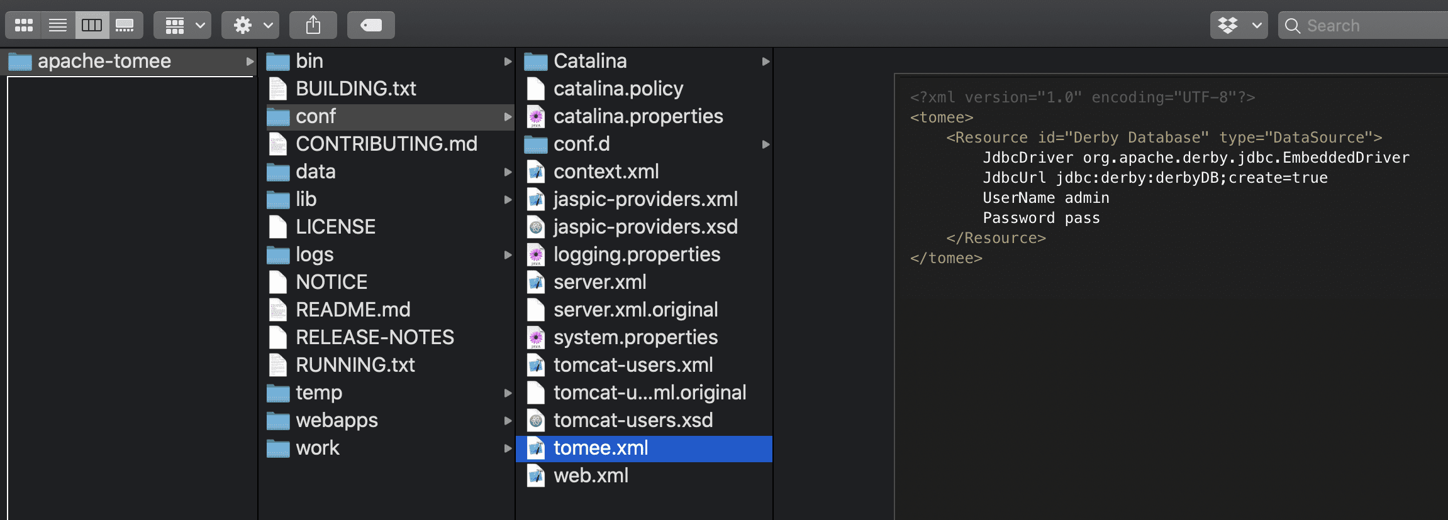

JDBC Configuration for a Webapp in TomEE

If you wish to configure a JDBC driver for a specific webapp than you add the <Resource> element as the root of the resources.xml file like this.

<Resource id="Derby Database" type="DataSource">

JdbcDriver org.apache.derby.jdbc.EmbeddedDriver

JdbcUrl jdbc:derby:derbyDB;create=true

UserName admin

Password pass

</Resource>

The resources.xml file should be created and stored under the webapp/WEB-INF/resources.xml in the source file for you webapp as shown below so that when you package the webapp the resources.xml file is included for deployment.

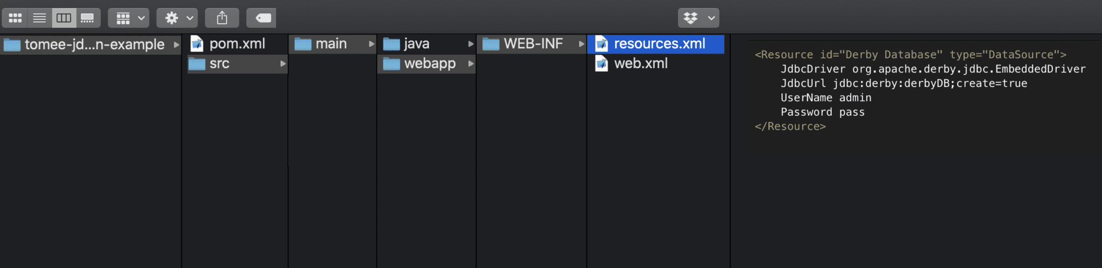

The declaration of a <Resource> in the resources.xml file will override any setting for the same <Resource> id in the tomee.xml file. In addition, you can set the TomEE system properties for a specific JDBC connection and that will take precedence over both the tomee.xml and the resources.xml configurations.

The JDBC Configuration Example Code for TomEE

You can find the source code on GitHub at the [tomitribe/tomee-jdbc-configuration-example](https://github.com/tomitribe/tomee-jdbc-configuration-example) project.

*NOTE: The example uses Java 8 when executing the Maven pom.xml file. Other versions of Java may not work.*

Simply clone the project from GitHub using the following command:

git clone https://github.com/tomitribe/tomee-jdbc-configuration-example.git

Next you can download, install, and run TomEE with a single Maven command by navigating into the project directory and executing the following command:

cd tomee-jdbc-configuration-example

mvn -e clean install tomee:run

*NOTE: The -e option tells Maven to output any execution errors when it starts and runs the TomEE server.*

The pom.xml file includes the TomEE Maven Plugin which takes care of downloading TomEE, installing the server, deploying the webapp and starting the Server.

*NOTE: You can stop the TomEE server by typing exit or quit at the prompt.*

To test that your web app was deployed and that JDBC was configured correctly, use your web browser or cUrl (on a new terminal) to send a GET request to the following address:

curl http://localhost:8080/jdbc-servlet/

JDBC Connection is valid @ timestamp = 1573829415802

If the output says that the connection “is valid” than you have successfully configured JDBC and connected to the database. Everytime you send this GET request the timestamp is updated.

The example injects a Derby DataSource into a raw Servlet using the @Resources annotation. The Servlet uses the injected Derby DataSource to create a [Connection](https://docs.oracle.com/javase/8/docs/api/java/sql/Connection.html) object and test if the connection is valid as shown in the full code listing below.

**package** org.superbiz;

**import** javax.servlet.http.HttpServlet;

**import** javax.servlet.*;

**import** java.io.*;

**import** javax.annotation.Resource;

**import** javax.sql.DataSource;

**import** java.sql.Connection;

**import** java.sql.SQLException;

**public** **class** **JdbcServlet** **extends** **HttpServlet** {

**private** **static** **final** long serialVersionUID = 8229511817604046163L;

@Resource(name = "Derby Database")

**private** DataSource dataSource;

**protected** **void** **doGet**(HttpServletRequest request, HttpServletResponse response)

**throws** ServletException, IOException {

PrintWriter writer = response.getWriter();

**try**(**final** Connection connection = dataSource.getConnection()){

boolean valid = connection.isValid(1000);

writer.print("\n JDBC Connection is " + (valid==true?"valid":"NOT valid") + " @ timestamp = "+ System.currentTimeMillis());

**return**;

} **catch** (SQLException e) {

// TODO Auto-generated catch block

e.printStackTrace();

}

writer.print("\n Unable to Connect");

}

}

For this example the Derby JDBC Driver was configured using the [webapp/WEB-INF/resources.xml](https://github.com/tomitribe/tomee-jdbc-configuration-example/blob/master/src/main/webapp/WEB-INF/resources.xml) configuration file.

As you can see, configuring a JDBC driver for use in TomEE really is not that complicated. All you need to know are the properties the driver requires and then to decide if you want the JDBC driver configured across the entire server or only for a specific webapp.